# CS 255 System Design Document Template

This template lays out all the different sections that you need to complete for Project Two. Each section has guidance to prompt your thinking. You will need to continually reference the interview transcript as you work to make sure that you are addressing your client’s needs. There is no required length for the final document. Instead the goal is to complete each section based on what your client’s needs are. Remove this note when you are finished, and replace all bracketed text with the relevant information.

## UML Diagrams

### UML Use Case Diagram

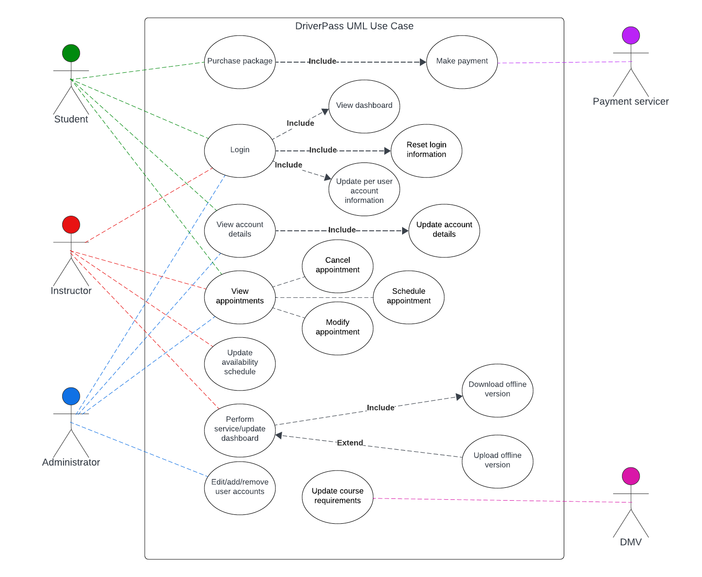

### UML Activity Diagrams

*Login/create account*

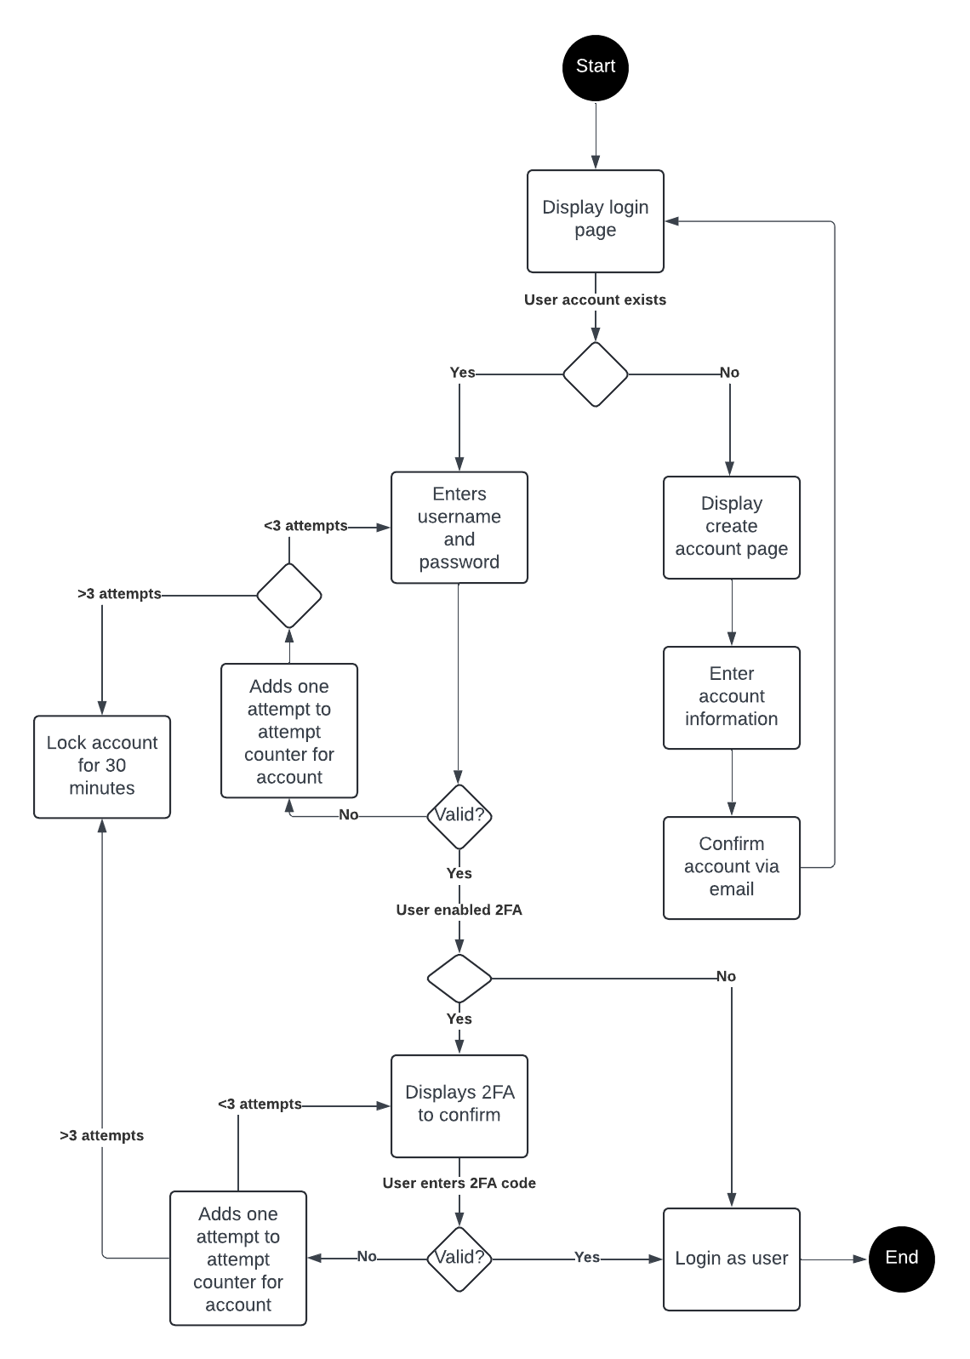

Modify/view appointments

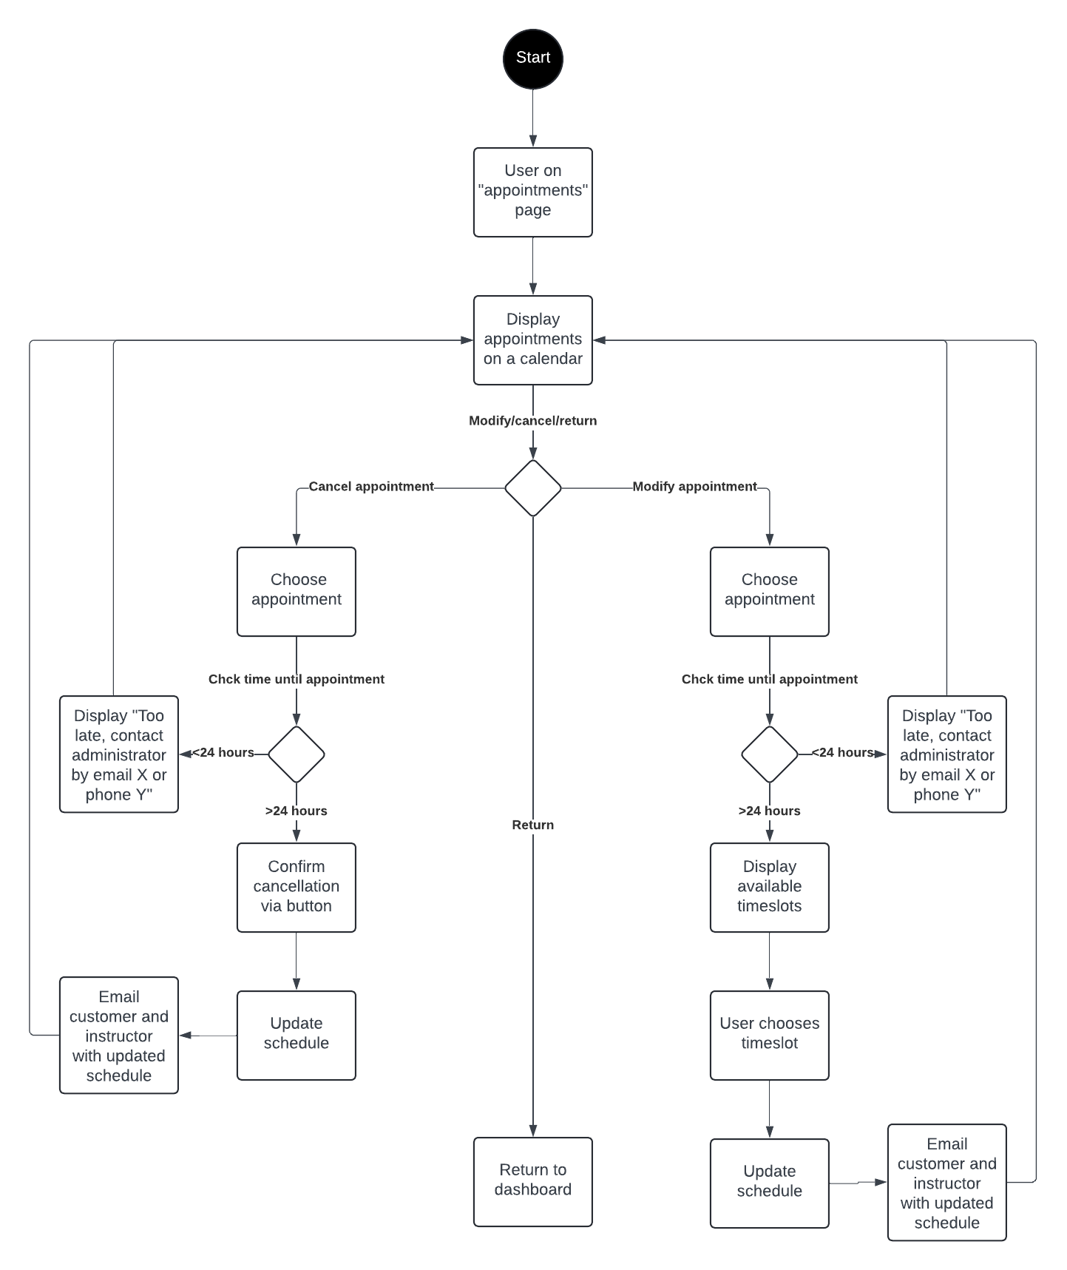

### UML Sequence Diagram

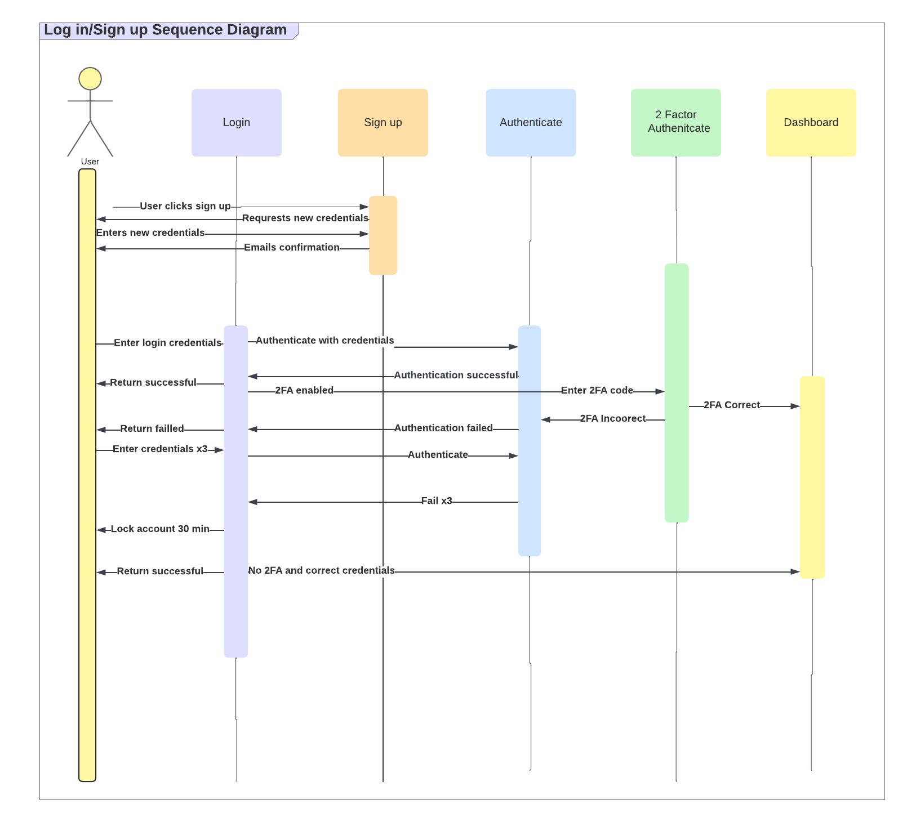

### UML Class Diagram

*]*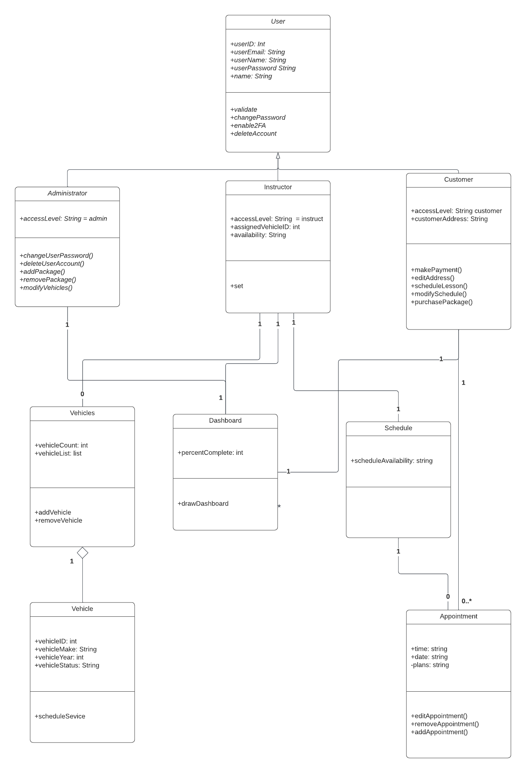

## Technical Requirements

The assumption is that the user has a cell phone or computer to access the website, and if a instructor the instructor had access at some point prior and downloaded an offline version of the data of the customer

The technical requirements include if self-hosted:

* 2 Dedicated servers for security
* Storage for the server
* A strong internet connection
* 1 Server with a web hosting software
* 1 Server with a database such as SQL and a windows server
* Backup software installed on both servers
* A hardware or software-based firewall
* Security software